­­­­

2024 Year 12 Comp Sci

Database and Programming Project

Great southern grammar

Task 6

Alec McDonald

# Table Of Contents

Table Of Contents 1

Part 1 – Planning 2

Tasks to be done part 1 Investigate. 2

Tasks to be done part 1 Design. 2

Tasks to be done part 2 Develop. 2

Tasks to be done part 2 Evaluate. 2

Time frame 3

Problem Outline: 3

Problem Description: 3

Sample Data: 4

Part 1 Design 5

Normalised Data: 5

Data Dictionary: 6

ER Diagram: 7

Part 2 Develop 8

SQL Queries Used to Create Database: 8

SQL Queries Used to Insert Data into the Database: 11

Part 2 Manipulate 15

SQL Queries Used to Manipulate Data: 15

# Part 1 – Planning

## Tasks to be done part 1 Investigate.

* Break down tasks to do.
* Outline problem.
* Problem Description.

## Tasks to be done part 1 Design.

* ER Diagram
* Relational Notation
* Data Dictionary
* Describe several queries.

## Tasks to be done part 2 Develop.

* Create an empty database.
* Create a script to insert data.
* Data validation
* Create several different queries.
* Create front end.

## Tasks to be done part 2 Evaluate.

* Reflects on success of your solution.
* Compare ER Diagram to database.
* Extra features implemented.
* Documentation of any known bugs or limitations
* Perform a developer retrospect.
* Document sources used to get information.

## Time frame

I have 5 weeks to complete this project.

Starting week 1 term 3 and to be completed by week 5 term 3.

|  |  |  |  |  |  |
| --- | --- | --- | --- | --- | --- |
|  | = Not Started |  | = Doing |  | = Finished |

|  |  |  |  |  |
| --- | --- | --- | --- | --- |
| Part | Key Point | Item | Due Date | Status |
| 1 | Investigate | Project Breakdown | Week 1 |  |
| Problem Outline | Week 1 |  |
| Problem Description | Week 1 |  |
| Design | ER Diagram | Week 2 |  |
| Relational Notation | Week 2 |  |
| Data Dictionary | Week 2 |  |
| Describe several queries | Week 2 |  |
| 2 | Develop | Create an empty database. | Week 3 |  |
| Create a script to insert data. | Week 3 |  |
| Data validation | Week 3 |  |
| Create several different queries. | Week 4 |  |
| Create front end. | Week 4 |  |
| Evaluate | Reflects on success of your solution | Week 5 |  |
| Compare ER Diagram to database. | Week 5 |  |
| Extra features implemented. | Week 5 |  |
| Documentation of any known bugs or limitations | Week 5 |  |
| Perform a developer retrospect. | Week 5 |  |
| Document sources used to get information. | Week 5 |  |

## Problem Outline:

The purpose of this project is to create a database and interactive terminal, or GUI made from python for the Great Southern Grammar catering team. Their current method of dealing with catering requests is through an online form which contains a series of checkboxes and user input boxes. This form does not reference any data sources to provide accurate or timely information to the users of the form. I aim to create a well organised and functional database to store information like requesters first and last name, email address, function name, function date, catering charges, type of catering, location of function, number of people catering for, time catering is requested for, what meal is being catered for, the costs of the meal that is being requested, a menu, specific catering requests, special dietary requirements, and an urgent request notice.

## Problem Description:

The database will need to consist of multiple tables such as requester information, location information, meal item (breakfast, morning tea, lunch, afternoon tea, dinner, other), event table, a catering table, a catering charges table and a menu table. To address the requirements of the client to have a space to store important information on the requester and event in a safe and easily retrievable way the database also includes a table that’s have meal items and their prices so that users can easily retrieve the cost of the meals being catered for. The database will also include the location table as it is important that the caterers have easy access to find out the location that they need to bring their services to. The Database would need bank details so the catering team can bill the expenses to the right people. This would need to be stored in a safe place as it is personal information like the requesters name and contact details.

Users might want to retrieve location information so that the caters know where they need to go, users might want to retrieve menu items so they know what they need to prepare for the function, they might want to be able to retrieve the function time and how many people are being catered for. These are all very important details that the catering team would be able to retrieve with relative ease. The catering team might want to retrieve the contact information of the requester as they might encounter a problem and need to contact the requester to clear up some details.

To achieve all this, I will be using SQLite and the SQL language to create a relational database. Using SQL, I will create around 7 tables to store the required data in order to meet the client’s requests. SQL queries will be used to make sure the database is functioning and in working order to be handed over to the client. The database will be integrated with a basic python interface that will easily allow the catering team to access all the information they need to provide their services to the customers functions.

Describing Queries

There are multiple queries that users will need to use such as select and inner join SQL queries. This will be used to retrieve information like retrieving the event details and requester name and contact details and showing them together. You could also retrieve the dietary requirement that need to be retrieved by selecting the dietary requirements for the event. The users can also retrieve the menu for the event so they can see what and how many meals they would specifically need to prepare.

Sample Data:  
Sample Data Can be found in the excel spreadsheet Linked bellow.

[Click me to see sample data](https://greatsoutherngrammar-my.sharepoint.com/personal/alec_mcdonald_student_gsg_wa_edu_au/Documents/.Year%2011/Computer%20Science/Task%206/Sample%20data.xlsx)

# Part 1 Design

## Normalised Data:

The normalised data can be found in the excel spreadsheet bellow.

[Click me to see normalised data](https://greatsoutherngrammar-my.sharepoint.com/personal/alec_mcdonald_student_gsg_wa_edu_au/Documents/.Year%2011/Computer%20Science/Task%206/Sample%20data.xlsx)

Alternatively, can be viewed in the photo bellow:

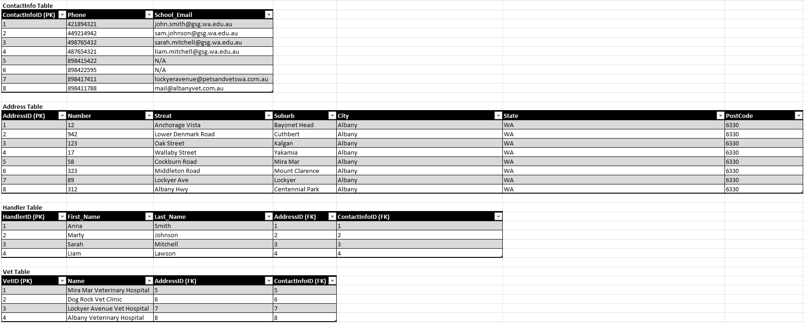

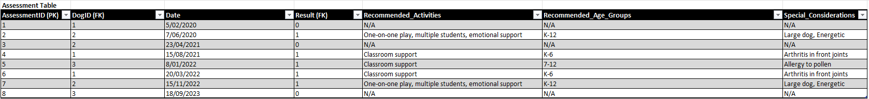

## Data Dictionary:

The normalised data can be found in the excel spreadsheet bellow.

[Click me to view the data dictionary](https://greatsoutherngrammar-my.sharepoint.com/personal/alec_mcdonald_student_gsg_wa_edu_au/Documents/.Year%2011/Computer%20Science/Task%206/Sample%20data.xlsx)

Alternatively, can be viewed in the photo bellow:

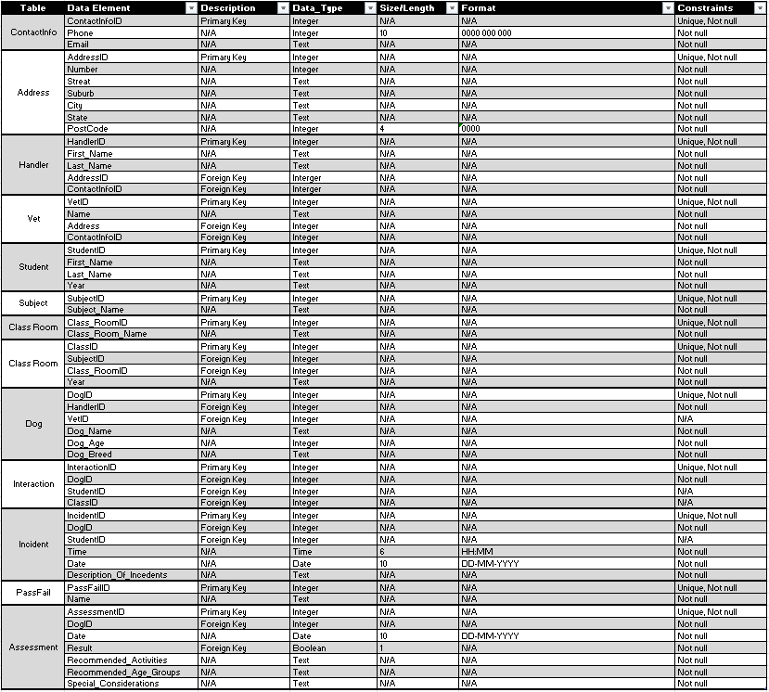

## ER Diagram:

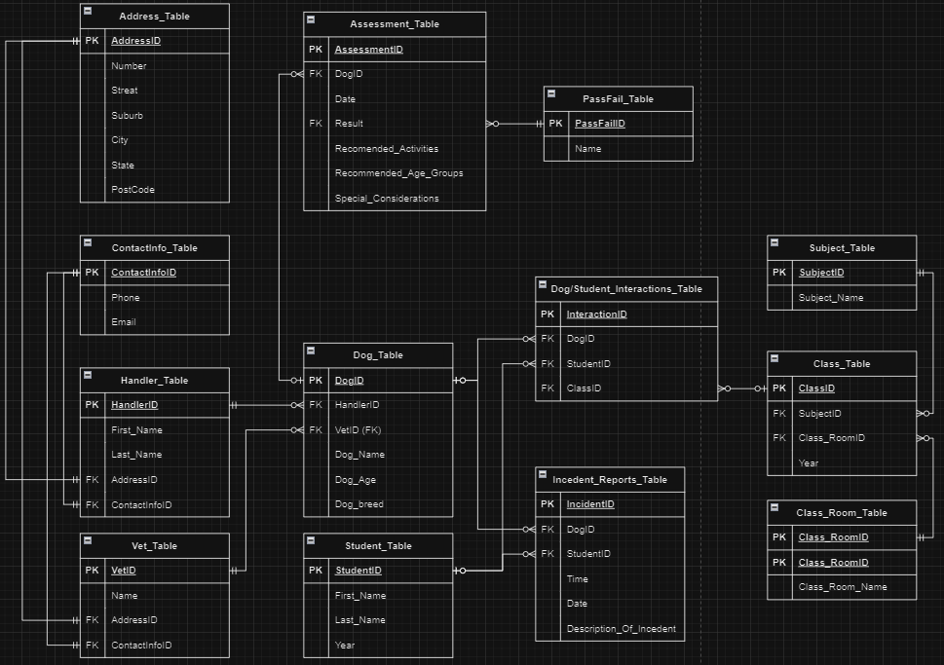

# Part 2 Develop

## SQL Queries Used to Create Database:

**CREATE** **TABLE** "Menu" (

MenuID **integer** **PRIMARY** **KEY** **AUTOINCREMENT** **NOT** **NULL**,

ItemName **text** **NOT** **NULL**);

**CREATE** **TABLE** "Event" (

EventID **integer** **PRIMARY** **KEY** **AUTOINCREMENT** **NOT** **NULL**,

EventName **text** **NOT** **NULL**,

NumberOfPeople **text** **NOT** **NULL**,

"Date" **date** **VARCHAR**(10) **NOT** **NULL**,

"Time" **time** **VARCHAR**(5) **NOT** **NULL**);

**CREATE** **TABLE** "TypesOfCatering" (

TypesOfCateringID **integer** **PRIMARY** **KEY** **AUTOINCREMENT** **NOT** **NULL**,

TypesOfCateringName **text** **NOT** **NULL**);

**CREATE** **TABLE** "AccountType" (

AccountTypeID **integer** **PRIMARY** **KEY** **AUTOINCREMENT** **NOT** **NULL**,

AccountTypeName **text** **NOT** **NULL**);

**CREATE** **TABLE** "Meals" (

MealID **integer** **PRIMARY** **KEY** **AUTOINCREMENT** **NOT** **NULL**,

MealName **text** **NOT** **NULL**,

MealPrice **float** **NOT** **NULL**);

**CREATE** **TABLE** "DietaryTypes" (

DietaryTypesID **integer** **PRIMARY** **KEY** **AUTOINCREMENT** **NOT** **NULL**,

DietaryTypesName **text** **NOT** **NULL**);

**CREATE** **TABLE** "User" (

UserID **integer** **PRIMARY** **KEY** **AUTOINCREMENT** **NOT** **NULL**,

AccountTypeID **integer** **NOT** **NULL**,

FirstName **text** **NOT** **NULL**,

LastName **text** **NOT** **NULL**,

PhoneNumber **integer** **VARCHAR**(10) **NOT** **NULL**,

Email **text** **NOT** **NULL**,

Username **text** **NOT** **NULL**,

Password **text** **NOT** **NULL**,

**CONSTRAINT** User_FK_1 **FOREIGN** **KEY** (AccountTypeID) **REFERENCES** AccountType(AccountTypeID));

**CREATE** **TABLE** "CardDetails" (

CardID **integer** **PRIMARY** **KEY** **AUTOINCREMENT** **NOT** **NULL**,

UserID **integer** **NULL**,

CardNumber **integer** **VARCHAR**(16) **NOT** **NULL**,

ExpiryDate **integer** **VARCHAR**(4) **NOT** **NULL**,

CVV **integer** **VARCHAR**(3) **NOT** **NULL**,

**CONSTRAINT** CardDetails_FK_1 **FOREIGN** **KEY** (UserID) **REFERENCES** **User**(UserID));

**CREATE** **TABLE** "Catering" (

CateringID **integer** **PRIMARY** **KEY** **AUTOINCREMENT** **NOT** **NULL**,

UserID **integer** **NOT** **NULL**,

MealID **integer** **NOT** **NULL**,

EventID **integer** **NOT** **NULL**,

CardID **integer** **NOT** **NULL**,

TypesOfCateringID **integer** **NOT** **NULL**,

SpecificCateringRequests **text** **NOT** **NULL**,

**CONSTRAINT** Catering_FK_1 **FOREIGN** **KEY** (UserID) **REFERENCES** **User**(UserID),

**CONSTRAINT** Catering_FK_2 **FOREIGN** **KEY** (MealID) **REFERENCES** Meals(MealID),

**CONSTRAINT** Catering_FK_3 **FOREIGN** **KEY** (EventID) **REFERENCES** Event(EventID),

**CONSTRAINT** Catering_FK_4 **FOREIGN** **KEY** (CardID) **REFERENCES** CardDetails(CardID),

**CONSTRAINT** Catering_FK_5 **FOREIGN** **KEY** (TypesOfCateringID) **REFERENCES** TypesOfCatering(TypesOfCateringID));

**CREATE** **TABLE** "EventMenu" (

EventMenuID **integer** **PRIMARY** **KEY** **AUTOINCREMENT** **NOT** **NULL**,

CateringID **integer** **NOT** **NULL**,

MenuID **integer** **NOT** **NULL**,

**CONSTRAINT** Catering_FK_1 **FOREIGN** **KEY** (CateringID) **REFERENCES** Catering(CateringID),

**CONSTRAINT** Catering_FK_2 **FOREIGN** **KEY** (MenuID) **REFERENCES** Menu(MenuID));

**CREATE** **TABLE** "EventDietaryRequirements" (

EvemtDietaryRequirementsID **integer** **PRIMARY** **KEY** **AUTOINCREMENT** **NOT** **NULL**,

DietaryTypesID **integer** **NOT** **NULL**,

CateringID **integer** **NOT** **NULL**,

Qty **integer** **NOT** **NULL**,

**CONSTRAINT** EvemtDietaryRequirements_FK_1 **FOREIGN** **KEY** (DietaryTypesID) **REFERENCES** DietaryTypes(DietaryTypesID),

**CONSTRAINT** EvemtDietaryRequirements_FK_2 **FOREIGN** **KEY** (CateringID) **REFERENCES** Catering(CateringID));

## SQL Queries Used to Insert Data into the Database:

**INSERT** **INTO** Menu (ItemName)

**VALUES**

('Chicken_Nuggets'),

('Pizza'),

('Fruit_Kabobs'),

('Vegetable_Sticks_with_Dip'),

('Sandwiches'),

('Macaroni_and_Cheese'),

('Cheese_and_Crackers'),

('Cupcakes'),

('Brownies'),

('Bacon_and_Eggs');

**INSERT** **INTO** Event (EventName, NumberOfPeople, 'Date', 'Time')

**VALUES**

('Science_Fair','150','2024-09-15','09:00'),

('Math_Olympiad','100','2024-10-03','08:30'),

('Art_Exhibition','200','2024-11-20','10:00'),

('Music_Concert','250','2024-12-05','18:00'),

('Drama_Play','180','2024-10-25','19:00'),

('Sports_Day','300','2024-09-30','08:00'),

('Book_Fair','220','2024-11-10','09:30'),

('Career_Day','120',' 2024-12-01','10:00'),

('Parent_Teacher_Conference','60','2024-10-15','16:00'),

('Cultural_Festival','350','2024-11-25','14:00');

**INSERT** **INTO** TypesOfCatering (TypesOfCateringName)

**VALUES**

('On_Site_Catering'),

('Off_Sight_Catering');

**INSERT** **INTO** AccountType (AccountTypeName)

**VALUES**

('Catering_Staff'),

('Users'),

('NotActive');

**INSERT** **INTO** Meals (MealName, MealPrice)

**VALUES**

('Breakfast','5.00'),

('Morning_Tea','5.00'),

('Lunch','7.50'),

('Afternoon_Tea','5.00'),

('Dinner','10.00');

**INSERT** **INTO** DietaryTypes (DietaryTypesName)

**VALUES**

('Gluten_Free'),

('Nut_Free'),

('Dairy_Free'),

('Vegetarian'),

('Vegan'),

('Halal'),

('Kosher'),

('Low_Sodium'),

('Low_Sugar'),

('Pescatarian'),

('Organic'),

('Soy_Free');

**INSERT** **INTO** "User" (AccountTypeID, FirstName, LastName, PhoneNumber, Email, Username, Password)

**VALUES**

('1','Alice','Smith','0412345678','alice.smith@gsg.wa.ed.au','alice.smith','Alice@1234'),

('2','Brian','Johnson','0498765432','brian.johnson@gsg.wa.ed.au','brian.johnson','Brian@1234'),

('2','Carol','Davis','0456789123','carol.davis@gsg.wa.ed.au','carol.davis','Carol@1234'),

('3','Olivia','Miller','0456123789','olivia.miller@gsg.wa.ed.au','olivia.miller','Olivia@1234'),

('1','Daniel','Brown','0423456789','daniel.brown@gsg.wa.ed.au','daniel.brown','Daniel@1234'),

('2','Emma','Wilson','0434567890','emma.wilson@gsg.wa.ed.au','emma.wilson','Emma@1234'),

('2','Frank','Taylor','0487654321','frank.taylor@gsg.wa.ed.au','frank.taylor','Frank@1234'),

('2','Grace','Anderson','0445678901','grace.anderson@gsg.wa.ed.au','grace.anderson','Grace@1234'),

('3','Noah','Harris','0491234567','noah.harris@gsg.wa.ed.au','noah.harris','Noah@1234'),

('1','Henry','Martinez','0478901234','henry.martinez@gsg.wa.ed.au','henry.martinez','Henry@1234'),

('2','Isabella','Thomas','0467890123','isabella.thomas@gsg.wa.ed.au','isabella.thomas','Isabella@1234'),

('2','Jack','Lee','0412340987','jack.lee@gsg.wa.ed.au','jack.lee','Jack@1234');

**INSERT** **INTO** CardDetails (UserID, CardNumber, ExpiryDate, CVV)

**VALUES**

('','4567123456789012','1225','123'),

('2','1234567890123456','1126','456'),

('3','2345678901234567','1024','789'),

('5','3456789012345678','0927','101'),

('6','4567890123456789','0823','202'),

('7','5678901234567890','0728','303'),

('9','6789012345678901','0622','404'),

('10','7890123456789012','0529','505');

**INSERT** **INTO** Catering (UserID, MealID, EventID, CardID, TypesOfCateringID, SpecificCateringRequests)

**VALUES**

('2','1','1','1','1',''),

('3','2','2','3','2','Cupcake_with_numbers_on_them'),

('5','3','3','4','1',''),

('6','4','4','5','2','Cupcakes_with_music_notes_one_them'),

('7','5','5','6','1',''),

('9','1','6','7','2','Packed_food_in_a_cooler'),

('10','2','7','8','1',''),

('2','3','8','2','2',''),

('3','4','9','1','1',''),

('5','5','10','4','2','Include_some_food_from_other_cultures');

**INSERT** **INTO** EventMenu (CateringID, MenuID)

**VALUES**

('1','4'),

('1','1'),

('1','10'),

('2','3'),

('2','8'),

('2','7'),

('3','4'),

('3','6'),

('3','5'),

('3','4'),

('3','9'),

('4','3'),

('4','8'),

('4','7'),

('5','4'),

('5','2'),

('5','9'),

('6','3'),

('6','5'),

('6','7'),

('6','10'),

('7','4'),

('7','8'),

('7','7'),

('8','3'),

('8','5'),

('8','8'),

('9','4'),

('9','9'),

('9','7'),

('10','3'),

('10','4'),

('10','1'),

('10','2'),

('10','5'),

('10','9');

**INSERT** **INTO** EventDietaryRequirements (DietaryTypesID, CateringID, Qty)

**VALUES**

('1','1','7'),

('2','2','8'),

('3','2','5'),

('4','3','2'),

('5','3','1'),

('6','3','6'),

('7','4','9'),

('8','4','5'),

('9','4','5'),

('10','4','4'),

('1','6','9'),

('2','6','5'),

('3','6','3'),

('4','6','3'),

('5','8','8'),

('6','8','6'),

('7','9','8');

# Part 2 Evaluate

## SQL Queries Used to Manipulate Data:

**SELECT** /*This query returns the handlerse contact information and which dog is theirs*/

d.Dog_Name **AS** Dog_Names,

h.First_Name ||' '|| h.Last_Name **AS** Handler_Name,

c.Phone **AS** Phone,

c.Email **AS** Email

**FROM** Handler h

**INNER** **JOIN** Dog d

**ON** d.HandlerID = h.HandlerID

**INNER** **JOIN** ContactInfo c

**ON** h.ContactInfoID = c.ContactInfoID;

**SELECT** /*This query returns the handlers name, dogs name and how many incidents the dog has*/

h.First_Name ||' '|| h.Last_Name **AS** Handler_Name,

d.Dog_Name **AS** Dog_Name,

**COUNT**(i.IncedentID) **AS** IncidentCount

**FROM** Handler h

**INNER** **JOIN** Dog d

**ON** h.HandlerID = d.HandlerID

**INNER** **JOIN** Incedents i

**ON** d.DogID = i.DogID

**GROUP** **BY** h.First_Name, h.Last_Name, d.Dog_Name

**HAVING** **COUNT**(i.IncedentID) > 0;

**SELECT** /*This query returns all incedent reports that have been made*/

d.Dog_Name **AS** Dog_Name,

h.First_Name ||' '|| h.Last_Name **AS** Handler_Name,

s.First_Name ||' '|| s.Last_Name **AS** Student_Name,

i.**Time**,

i.**Date**,

i.Description_Of_Incedent

**FROM** Dog d

**INNER** **JOIN** Handler h

**ON** d.HandlerID = h.HandlerID

**INNER** **JOIN** Incedents i

**ON** d.DogID = i.DogID

**LEFT** **JOIN** Student s

**ON** i.StudentID = s.StudentID;

**SELECT** /*This query returns all interactions each dog has with students and classes*/

d.Dog_Name,

s.First_Name ||' '|| s.Last_Name **AS** Student_Name,

i.ClassID

**FROM** Interactions i

**LEFT** **JOIN** Student s

**ON** s.StudentID = i.StudentID

**LEFT** **JOIN** Dog d

**ON** d.DogID = i.DogID;

**SELECT** /*This query returns how many interactions each dog has and their handler*/

h.First_Name ||' '|| h.Last_Name **AS** Handler_Name,

d.Dog_Name,

**COUNT**(i.InteractionID) **AS** Interaction_Count

**FROM** Handler h

**INNER** **JOIN** Dog d

**ON** h.HandlerID = d.HandlerID

**INNER** **JOIN** Interactions i

**ON** d.DogID = i.DogID

**GROUP** **BY** h.First_Name, h.Last_Name, d.Dog_Name

**HAVING** **COUNT**(i.InteractionID) > 0;

**SELECT** /*This query returns the ammount of assessment a dog has, the last assessment they had and their next assessment date*/

d.Dog_Name,

**COUNT**(a.AssessmentID) **AS** Assessment_Count,

**MAX**(**STRFTIME**('%Y-%m-%d', **SUBSTR**(a.**Date**, 7, 4) || '-' || **SUBSTR**(a.**Date**, 4, 2) || '-' || **SUBSTR**(a.**Date**, 1, 2))) **AS** Last_Assessment_Date,

**STRFTIME**('%Y-%m-%d', **DATE**(**SUBSTR**(a.**Date**, 7, 4) || '-' || **SUBSTR**(a.**Date**, 4, 2) || '-' || **SUBSTR**(a.**Date**, 1, 2), '+1 year')) **AS** Next_Assessment_Date

**FROM** Assessments a

**INNER** **JOIN** Dog d

**ON** d.DogID = a.DogID

**GROUP** **BY** d.Dog_Name

**HAVING** **COUNT**(a.AssessmentID) > 0;

**SELECT** /*This query returns each dogs last assessment information*/

**MAX**(**STRFTIME**('%Y-%m-%d', **SUBSTR**(a.**Date**, 7, 4) || '-' || **SUBSTR**(a.**Date**, 4, 2) || '-' || **SUBSTR**(a.**Date**, 1, 2))) **AS** Assessment_Date,

d.Dog_Name,

p.Name **AS** **Result**,

a.Recommended_Activities **AS** Recommended_Activities,

a.Recommended_Age_Groups **AS** Recommended_Age_Groups,

a.Special_Considerations **AS** Special_Considerations

**FROM** Assessments a

**LEFT** **JOIN** Dog d

**ON** d.DogID = a.DogID

**LEFT** **JOIN** PassFail p

**ON** a."Result" = p.PassFailID

**WHERE** **STRFTIME**('%Y-%m-%d', **SUBSTR**(a.**Date**, 7, 4) || '-' || **SUBSTR**(a.**Date**, 4, 2) || '-' || **SUBSTR**(a.**Date**, 1, 2)) = (

**SELECT** **MAX**(**STRFTIME**('%Y-%m-%d', **SUBSTR**(a2.**Date**, 7, 4) || '-' || **SUBSTR**(a2.**Date**, 4, 2) || '-' || **SUBSTR**(a2.**Date**, 1, 2)))

**FROM** Assessments a2

**WHERE** a.DogID = a2.DogID)

**GROUP** **BY** d.DogID;

**SELECT** /*This query returns all vet information*/

v.Name **AS** Name,

c.Phone **AS** Phone,

c.Email **AS** Email,

a.**Number** ||' '|| a.Streat ||' '|| a.Suburb ||' '|| a.City ||' '|| a.State ||' '|| a.postcode **AS** Address

**FROM** Vet v

**LEFT** **JOIN** ContactInfo c

**ON** v.ContactInfoID = c.ContactInfoID

**INNER** **JOIN** Address a

**ON** v.AddressID = a.AddressID;

**SELECT** /*This query returns how many dogs are in the database*/

**COUNT**(d.DogID) **AS** Dog_Count

**FROM** Dog d;

**SELECT** /*This query returns the hour that most incedents happen*/

**CAST**(**STRFTIME**('%H', **SUBSTR**(i.**Time**, 1, 5) || ':00') **AS** **INTEGER**) **as** **Hour**, **COUNT**(*) **as** Incident_Count

**FROM** Incedents i

**GROUP** **BY** **Hour**

**ORDER** **BY** Incident_Count **DESC**

**LIMIT** 1;